- Before starting any import. Manually backup your database. Please don’t skip this step or you may really regret it!
- Setup a CSV file with the information you want to import. Generally it is setup as followed (Last Name, First Name, Credential Number, Credential Type, Reference)
- Open the Configurator program (the main WAMS program)
- Click Applications at the top
- Choose Wi-Q System Administrator
- Click Wi-Q Importer
- Choose the correct segment from the drop down menu at the top of the page
- If your CSV file has Field Headers in the first row of the CSV file make a tick mark next to that option
- Click Show Additional Fields button
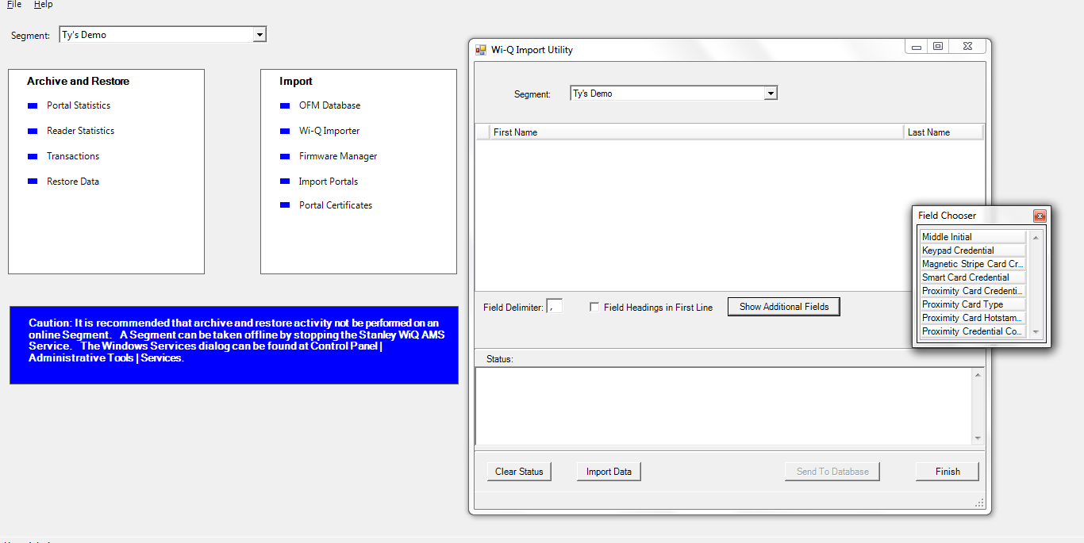
- Double click any required fields that are in your CSV file
- Close that Field Chooser box
- If the field tags are in an incorrect order simply drag the field tags in the order that corresponds to your CSV file
- Click Import Data button at the bottom
- Choose Common Separated Value .CSV file type just above the Open button
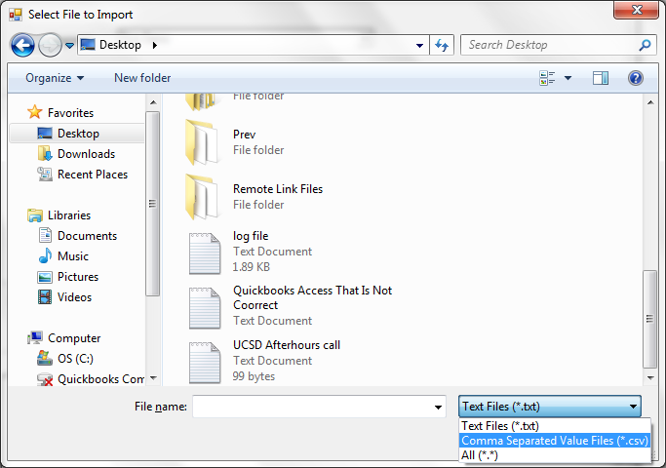
- Browse to the CSV file that you want to open and click on it
- Click Open to select that file
- Look at your data to make sure that it is what you expected. And that the column names match the data that is in the cells below it.
  - If the data does NOT match what you expected. Close the Wi-Q Import Utility window and start again
  - If the data does match then click Send To Database
- A warning box will come up indicating how many users will be imported if it is correct, click Yes
- In the Status window the records will soon start to populate and when it finishes you will see a line that says “(X Number of) Users processed!”
- Before proceeding I would recommend coping all of the information in the Status window and pasting it into a text document. In the text document carefully review that log information to see if there were any errors or skips. If there are it will tell you which Record (or line) it had a problem with. You would want to address this in your CSV or Omnilock program depending on the issue.
- Click Finish button
- Close out of all Omnilock programs
- Start the Configuration program back up and verify that your users are in the system.
- Now you will have to assign them to a group before they can start using their credentials.

Important notes about preparing your data

- Make sure that none of your credentials have any letters or special characters
  - If it does and it’s imported you will NOT get a warning. It could cause an issue that will lock all users out not just the specific user with a problem.
- All names must be 20 characters or less. First Name (-20) and Last Name (-20).
  - If you don’t do this an import the file it will skip that record entirely. It will not automatically truncate it.
  - That doesn’t mean you can have a user with a last name of 25 characters and a first name of 16 characters. The system will skip this type of record as well.
- All users have to have different names.
  - If you have two John Does than you need to make them unique. (i.e. John Doe-1 and John Doe-2…or however you would like as long as they are unique)
  - You will not get an error indicating a problem. Instead it will just say existing user credential updated. Which will make one of your users credentials not work.
  - The system does not validate against middle initial. So it will identify two users the same if they have the same first and last name but different middle initial.
- Credentials have to be unique
  - If the credential is already in the system it will add the users record but will not add the credential.

